EXTENDED ABSTRACT TEMPLATE

(*** Please remove all the comments printed in red ***)

TITLE: BOLD, UPPER CASE, TIMES NEW ROMAN, 14 PT CENTERED

Mamoru Tanahashi^{1*}, Yongchan Kim², Sumanta Acharya³, Koji Fukagata⁴

¹ Department of Mechanical Engineering, Tokyo Institute of Technology, Japan
² School of Mechanical Engineering, Korea University, Republic of Korea
³ The Mechanical, Materials, and Aerospace Engineering Department, Illinois Institute of Technology, USA
⁴ Department of Mechanical Engineering, Keio University, Japan

Abstract

This guide has been prepared for authors of extended abstract to be presented at The Third Pacific Rim Thermal Engineering Conference (PRTEC2024), December 15-19, 2024, Honolulu, Hawaii, USA. Authors are requested to follow these guidelines to achieve uniformity in the presentation of the proceedings. The main format of the extended abstract is as follows. Text: Times New Roman (or equivalent), 11 pt, left and right justified. Headings: Times New Roman, all capitals, 12 pt, centered. Page size A4 (210 × 297 mm); 20 mm borders all round; paper title starts at 40 mm from the top of the page except for the first page. Convert the manuscript to a single PDF file and submit it to the Online Submission System (https://www.jsme.or.jp/ted/PRTEC2024/) by the electrical format. The abstract should summarize the key findings in your study and should be in a single paragraph no more than 250 words. It should give an account of the most relevant contributions of the paper. It is also important to briefly indicate the goal, the methods, the results, and the conclusions. Avoid abbreviations, diagrams, and references. It must be self-contained and understandable without reference to the text.

KEYWORDS: Times New Roman, 10 pt, Convection, Computational methods, Heat exchanger, Cooling turbine blade, Film cooling, High temperature

1. INTRODUCTION (Details for Submitting Extended Abstract)

The Extended abstract must be formatted using this template and submitted by August 15, 2024 for review. The final version of the Extended Abstract must be submitted by September 30, 2024 for inclusion in the proceedings. The final version of the extended abstract that does not conform to the correct format will not be included in the proceedings. There will be no opportunity to alter it after the submission of the final version.

It is assumed that the corresponding author will make a presentation at the conference. Each accepted extended abstract must have at least one paid regular or student registration by October 15, 2024 to ensure that their presentation is included in the Conference Program.

2. LENGTH AND LAYOUT

The extended abstract should be in 2 - 5 pages in A4 size (210 × 297 mm) including tables, figures and references. The extended abstract may include color figures. The file size should not exceed 4 Mbytes after conversion to a PDF file.

The layout of the extended abstract should follow the style of this document, starting with the title, name(s) of author(s) and affiliation(s). Put a blank line between paragraphs.

Title: The title should appear 40 mm below the top edge of the page. It should be brief, clear and descriptive. Use Times New Roman 14 pt. all bold capital letters (except if formulae or symbols appear in the title), centered on the width of the typing area. Authors’ names should be in lower-case letters in bold and the affiliations should be in no bold.

ABSTRACT: A brief abstract (100 - 250 words) should appear beneath the affiliation of the author(s). It should give an account of the most relevant contributions of your study. It is also important to indicate briefly the goal, the methods, the results, and conclusions. Avoid abbreviations, diagrams, and references. It must be complete and understandable without reference to the text. Leave a blank line between the Author’s affiliation and the Abstract. Leave a blank line between the abstract and keywords.
KEYWORDS: Keywords can be selected to describe the feature of the extended abstract. Leave two blank lines between keywords and the first major heading.

Header and footnotes: The header includes the Paper number. Please insert your presentation ID supplied by the Online Submission System, e.g., PRTEC-23456, if your presentation ID is PRTEC-23456. The footnote of the first page contains E-mail address of the corresponding author. Note that this “formal” corresponding author can be different from the “practical” corresponding author registered on the submission system. Do not edit the copyright line. We do not transfer the copyright for the authors’ convenience. The copyright line should always appear as “Copyright © 2024 by The Author(s). Distributed by JSME, KSME, and ASTFE with permission.” Do not substitute the authors’ names in the copyright line.

3. HEADINGS AND EQUATIONS

If your extended abstract is divided into sections and subsections, please use the format adopted here, in which the first-level headings are in 12 pt bold capitals, centered. Put two blank lines before the heading and a blank line after the heading.

3.1 Second-Level Headings The second-level headings should be in 12 pt bold lower case (initial capital), left aligned.

Third-level headings. The third-level headings should be placed at the beginning of a paragraph. Capitalize only the first letter of the whole subhead ended with a period and underline it (if possible, make the subhead italic). With two-letter spacing, begin typing the text on the same line and continue the text without indenting again. Leave one line space above.

Equations should be typed in position with an appropriate space above and below to distinguish them from the text. Use common fonts like Times New Roman in your math equations. Do not insert equations in a non-editable picture format. All equations should be numbered, e.g.,

(1)
and
. (2)

An equation is a part of the text: do not isolate the equation. Put relevant punctuations. The Equation number should be flush right with a line space above and below the equation. Align equal signs when
equations are stacked with no intervening words.

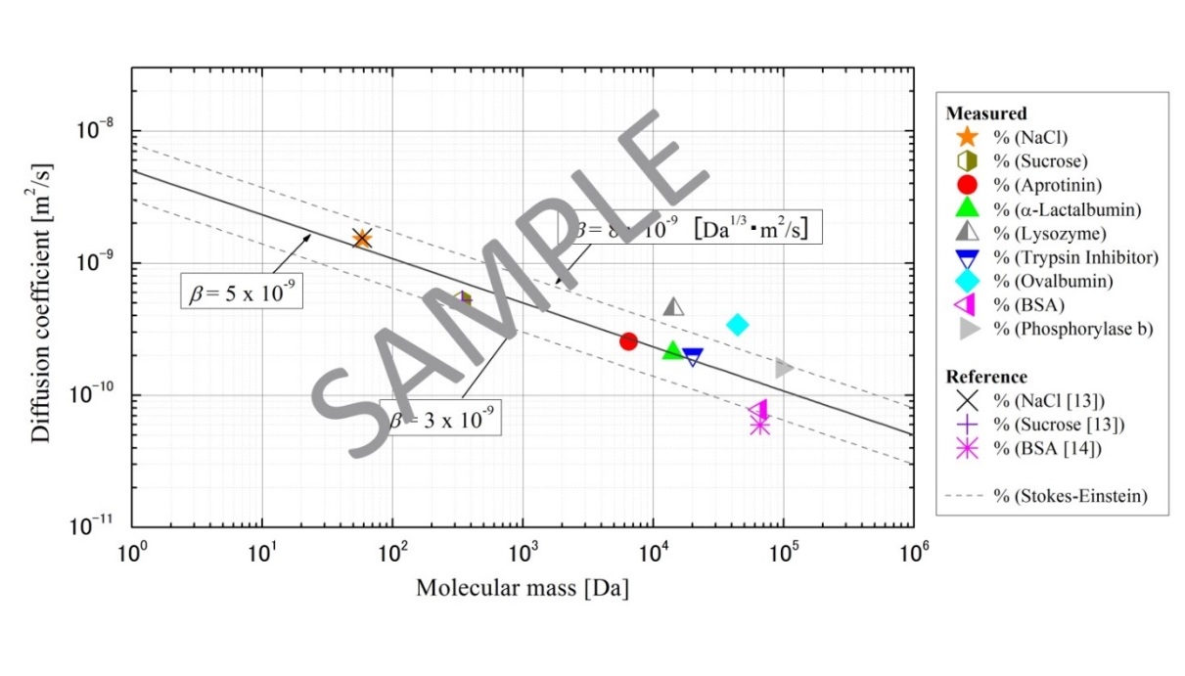
Fig. 1 One-line figure caption is centered under the figure. Make a space above the figure caption.

Subscripts and superscripts should clearly be typed, and the manuscript should be reviewed carefully to ensure there is no ambiguity in presentation. Numbers and letters that are intended to be subscripts or superscripts should not be aligned with the rest of the text.

All data should be reported in SI units. Decimals should always be shown by periods and not by commas or centered dots.

4. FIGURES AND TABLES

4.1 Figures Care should be taken to ensure that figures are contained within the typing area. All original drawings should be prepared. As a general rule, lettering (i.e., font type and size) in the figures should be comparable to that in the text. Color and black/white photographs are allowed in digital format with sufficient resolution to permit high-quality reproduction, and imported into the manuscript. Use or insert .jpg, .tiff, .gif, or similar program files for illustrations. Do not use PowerPoint or graphic constructions as they provide poor quality illustrations.

Figures should be numbered consecutively, and they are referred as, e.g., Fig. 1, with a single letter space between the word “Fig.” and the Arabic numeral, but do not abbreviate it if it appears at the beginning of a sentence; namely, not “Fig. 1 shows …” but “Figure 1 shows …” at the beginning of a sentence.

Place figures centered on the width of the text page, either at the top or bottom of the page as close as possible to their first mentioning text. Figure captions should appear below the respective figure. Type the word “Fig.” and its number followed by two-letter space. Then, type the caption single spaced, with an initial capital for the first word and for proper nouns only. Provide relevant spacing around the figure.

4.2 Tables When tables are referred in the text, they should be referred to as Table 1, Table 5, etc. (i.e., with a single letter space between the word “Table” and the Arabic numeral). Separate the title from the column heads, ranks within column heads, column heads from table body, and table body from table footnotes or source.

Table 1 The table caption is above the table. Captions that are two or more lines are flushed left, one line space above and below the caption.

Case | Diameter, (mm) | (Hz) | We | St
1 | 0.5 | 731 | 117 | 0.15
2 | 0.5 | 1799 | 620 | 0.16
3 | 1.3 | 198 | 124 | 0.17

Place tables centered on the width of the text page, either at the top or bottom of the page as close as possible to their first mentioning text. Table captions should appear above the respective table. Each table should have at least a two-line space both above the table and between the table and the start of the following text.

The first letter of the word “Table” should be capitalized, followed by the table number and period, then the caption with the first letter of main words capitalized, all centered above the table as shown below. Use horizontal rules above and below. Tables are in Times New Roman, 11 pt: one-line heading, centered; two- or more-line heading flush left. The table caption is placed above the table, with one line space above and below the caption. Type size of the body of the table depends on the size of the table, adjust type size accordingly.

5. NON-ENGLISH SPEAKING AUTHORS

Authors from non-English speaking countries are requested to find persons who are competent in English and familiar with the scientific language and can edit their manuscripts before submission. Reviewers may not be relied on to make corrections of English expression, spelling, etc. As there is no editing stage for publication-ready manuscripts, it is the responsibility of authors to ensure that the presentation of their extended abstracts reaches the same high level as that of the work they describe.

6. CONCLUSIONS

Paper Size and Length: A4 (210 × 297 mm) and 2-5 pages.
Margins: 20 mm margins all round as in the Full Paper Template.
Line Spacing: Single-spaced with one blank line between paragraphs. No paragraph indentation.
Justification: Full justification.
Page Numbering: Pages should be numbered.
Figures and tables: Figures and tables should be placed at the top or bottom of the page on which they are first mentioned if possible, on the next page if not. Do not gather them at the end of the extended abstract.
Submission: The Extended Abstract should be converted to a single PDF file whose size is no more than 4 Mbytes, and submitted to the Online Submission System (https://www.jsme.or.jp/ted/PRTEC2024/).
Submission Deadline for review: Extended Abstract for review should be submitted by August 15, 2024. Notification of acceptance will be made by August 31, 2024.
Submission Deadline for final version: All contributors must upload the final version of Extended Abstract for inclusion in the proceedings by September 30, 2024 even if there is no modification from the initial Extended Abstract. The Final Extended Abstract that does not conform to the correct format will not be included in the proceedings. There will be no opportunity to alter it after the submission of the final version.

ACKNOWLEDGMENTS

Acknowledgments should be placed immediately following CONCLUSIONS, if necessary.

NOMENCLATURE

The editors of the major heat transfer journals have adopted a common list of symbols. The symbol list can be found in Journal of Heat Transfer, 121, 770-773 (1999). All authors should use these symbols for the extended abstract submitted for this conference. The symbols defined in this common list need not be included in the nomenclature list; only symbols unique to the extended abstract should be listed here. A short nomenclature defining unusual or non-standard symbols should be placed immediately above the REFERENCES. SI Units must be used.

Be dimensionless variable ( - )
Ĉ second variable (s²)
Q_{A} third variable (kJ)
w_{x} fourth variable (m²/s)
ϕ(Ω) function
ζ dimensionless variable ( - )
Ω fifth variable ( s⁻¹ )

REFERENCES

Reference list at the end of the article should be numbered consecutively in the order they are mentioned, using Arabic numerals in square brackets [4] and formatted according to the following samples. Incorrectly formatted reference lists will be returned to the author for correction before acceptance. References should be in Times New Roman, 9 pt, justified copy, first line flush left, remaining lines indented (see, Reference list exemplified below).

[1] Author, A. A., Author, B. B., and Author, C. C., “Title of article,” Title of Journal, 12 (Volume), 231-251 (Pages) (2009). (Year) Journal Paper Having Conventional Page Numbers This note means that this is an example of a journal paper. The same applies to the following lines. Please remove all these red bold-face texts in your manuscript.
[2] Author, A. A., Author, B. B., and Author, C. C., “Title of article” Title of Journal, 34, 123456 (2014). Journal Paper with an Article Number
[3] Author, A. A. and Author, B. B., “Title of article,” Title of Journal. doi: abced/fghij/12345. Journal Paper Published Online with DOI
[4] Author, A. A. and Author, B. B., “Title of article,” Title of Journal, 56. Retrieved month day, year, from http://www.someaddress.com/full/url/, (Date of publication). Other Online Scholarly Journal Article
[5] Nield, D. A. and Bejan, A., Convection in Porous Media, New York: Springer-Verlag, pp. 125–176 (2005). Book
[6] Buyevich, A. and Alexandrov, D.V., Heat Transfer in Dispersions, Connecticut: Begell House, Available at http://www.edata-center.com/ebooks/b7f98f1e271b3e77a.html/ EBooks [accessed May 5, 2005] (2005). E-Book
[7] Yang, W. and Kim J. H., Eds., Rotating Machinery, New York: Begell House (1992). Edited Book
[8] Nishikawa, K. and Ito, T., “Augmentation of Nucleate Boiling Heat Transfer by Prepared Surfaces,” In Mizushina, T. and Yang W. J., Eds., Heat Transfer in Energy Problems, Washington, D.C.: Hemisphere Publishing, pp. 111–1182 (1982). Chapters of Edited Book
[9] Ma, T. M., “Effects of Geometrical Shapes of Reentrant Grooves on Boiling Heat Transfer from Porous Surfaces,” Heat Transfer 1986, Proc. of 8th Int. Heat Trans. Conf., vol. 4, pp. 2013–2018 (1987). Conference Proceedings
[10] Richmond, J., Steady State Thermal Conductivity, Ph.D. Thesis, University of Connecticut (2004). Dissertation
[11] Author, A. A. and Author, B. B., Title of document. Retrieved month day, year, from http://Web address, (Date of publication). Webpages: Nonperiodical Web Document
[12] Author, A. A. and Author, B. B. Title of article. In Title of book or larger document (chapter or section number). Retrieved month day, year, from http://www.someaddress.com/full/url/, (Date of publication). Chapter or Section of a Web Document

